OBJECTIVES

GENERAL
- Understand the main information security principles CIA (Confidentiality, Integrity and Availability) and its importance for the information assets.

SPECIFIC:
- Make people aware about the importance of information security.
- Learn to classify information assets to prioritize security controls.

In the next link, you will find all the information security terminology that we will use in this course and the associated laboratories.
https://www.sophos.com/en-us/security-news-trends/security-trends/threatsaurus.aspx

Make groups of three students and answer the following questions:

SECTION ONE

Case study: Security for Internet of Things (IoT)
- Explain what is Internet of Things (IoT)
El internet de las cosas es la conexión de los elementos o cosas que utilizamos a diario, con la internet.
- List at least 5 examples of Internet of Things devices that can be found in your surroundings
- Refrigeradores
- Relojs
- televisores
- Alarmas
- Bombillas
- vehículos
- View the following video about attacks over Internet of Thing devices and answer the following questions:
  - ¿What information assets (Hardware, software, information, network, persons, etc.) were compromised in the attack?

Esta siendo comprometida la confidencialidad de la información, ya que se estaba compartiendo información que únicamente debería ser conocida por el propietario del vwhiculo.

  - Identify possible impact (reputational, operative, legal) for the manufactured of the IoT devices which are consequence of the attack. Support your answer with some news or information of similar cases.

Es posible que los usuarios de esta referencia y marca de vehículo, se sientan vulnerables ante ataques, por tanto posiblemente dejen de utilizarlos, además podrian difundir su experiencia con otras personas, lo cual dañaría gravemente la reputación de esta empresa y sus ingresos. Es posible que algún usuario molesto por este problema de seguridad tome la decision de denunciar a la empresa por comprometer la confiabilidad de la informacion de su vehículo.

  - ¿How was affected each one of the information security principles (CIA)?

Fue afectada la confidencialidad de la información, ya que se entregaban datos
a terceros, los cuales no tenian el permiso para acceder a esta información. Además fue afectada la accesabilidad de los datos ya que se limitaba al usuario en algunas de las caracterizticas que tenia su vehículo.

- Description of an attack scenario for a vehicle
https://www.youtube.com/embed/JDLVlSXNE0o?start=736&end=865

- Execution of an attack scenario over a vehicle
https://www.youtube.com/embed/JDLVlSXNE0o?start=1060&end=1330

SECTION TWO

- Describe a real case where you consider that your personal information was vulnerated. Describe which were the attack consequences and what you did after the attack.

- En determinado ocación fui victima de un ataque de denegación de servicios, en el cual se enviaban archivos maliciosos al router de mi red, esto generaba la desconección de mi dispositivo movil, posteriormente, mi dispositivo mobil intenta reconectarse a la red, la cual estaba siendo monitoreada por el atacante, en el proceso de reconección de mi dispositivo mobil con la red el dispositivo mobil envia paquetes con la contraseña de red, el atacante decifra la contraseña de red y logra ingresar a mi red.
- Luego de algún tiempo de identificar menor velocidad de conección a internet, realice una revision de dispositivos conectados y detecto algunos dispositivos conectados a mi red los cuales son agenos a mi propiedad, debido a mis bajos conocimientos en seguridad, únicamente cambio la contraseña de mi red wifi, asignando una contraseña mas larga a la anterior.

SECTION THREE

Case study: National cyber-defense and critical infrastructures

- ¿What is cyber-defense, cyber-attack, and cyber-intelligence? ¿What are the differences between these concepts?
Ciberdefensa es el conjunto de acciones y/u operaciones activas o pasivas desarrolladas en el ámbito de las redes, sistemas, equipos, enlaces y personal de los recursos informaticos y teleinformaticos de la defensa a fin de asegurar el cumplimiento de las misiones o servicios para los que fueran concebidos a la vez que se impide que fuerzas enemigas los utilicen para cumplir los suyos.

ciberataque es la explotación deliberada de sistemas informáticos, empresas y redes dependientes de la tecnología. Estos ataques utilizan códigos maliciosos para alterar la lógica o los datos del ordenador, lo que genera consecuencias perjudiciales que pueden comprometer información y provocar delitos cibernéticos, como el robo de identidad.

la adquisición y el análisis de información para identificar, rastrear y predecir las capacidades, intenciones y actividades cibernéticas que apoye la toma de decisiones.

<

- ¿What is considered critical infrastructure?
- View the following video about attacks over critical infrastructures and answer the following questions:
  - ¿What information assets (Hardware, software, information, network, persons, etc.) were compromised in the attack?

  - ¿How was affected each one of the information security principles (CIA)?
  - ¿What can be done against these kinds of threats? Explain your answer.

- Description of a Denial of service scenario using domestic routers
https://www.youtube.com/embed/J3_YAjUWNp4?start=859&end=1053

- Execution of a Denial of Service attack using domestic routers
https://www.youtube.com/embed/J3_YAjUWNp4?start=1385&end=1518

SECTION FOUR

Case study: Identify information assets in a company

- Download a local instance of the solution SimpleRisk from:
https://www.simplerisk.com/download

- In step 1 select “Use a pre-installed SimpleRisk Virtual Machine Image”
- In step 2 download a vmware or virtualbox ovf/ova file
- In step 3 read the document to import, bootstrap the virtual machine, set an IP address and get web access to the interface.

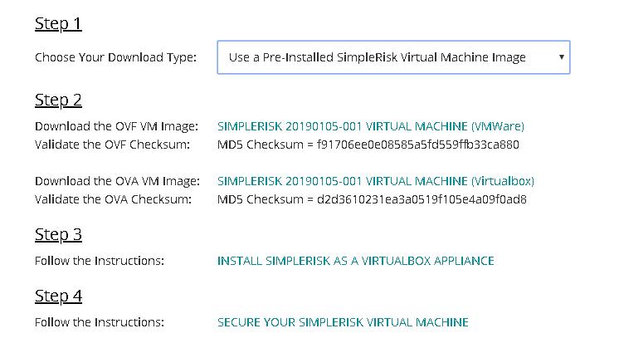.
- Network configuration: Set the network card of the virtual machine in “bridge mode”, taking care of having mark at least on adapter (Wifi or Ethernet) as show in the following image:
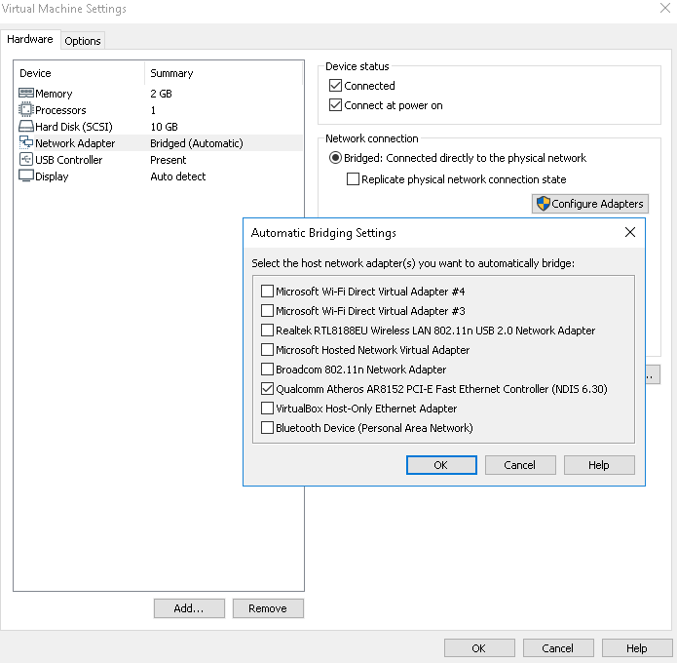

- Bootstrap the virtual machine, unlock (decrypt) the disk using password: simplerisk
- Login using credentials: simplerisk/simplerisk
- Use the ifconfig -a command to see the name of all the interfaces you have in your virtual machine. In my case I had two ones: ens33 and lo.
- As Simplerisk is installed on Ubuntu 18.04 platform, set the IP address modifying the following file /etc/netplan/01-netcfg.yaml in the following way:

For this case I chose the IP: 10.10.3.113/24 with gateway 10.10.3.1 and DNS 10.1.0.17.
In the Networks Laboratory you can chose any available IP from the range 10.2.77.X/16 with gateway: 10.2.65.1 and DNS 10.2.65.60.

Netplan file before being modified
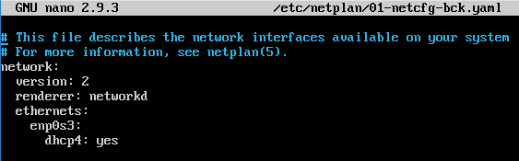

Netplan file after being modified
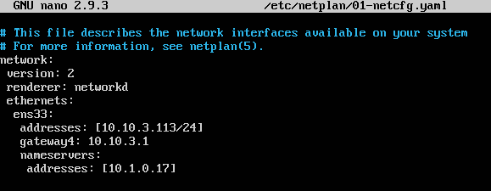

Netplan do not accept TABS and is strict with identation, so only use spaces inside the 01-netcfg.yaml document.

- Apply changes typing: sudo netplan apply
- In configure, go to “Add and remove values” and in status delete all existing status and create the followings: Accepted, Avoided, Mitigated and Transferred.

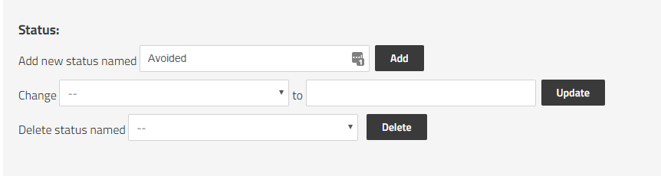

After setting the network card you should be able to start a browser and access the SimpleRisk interface where you can log in using the credentials admin/admin:

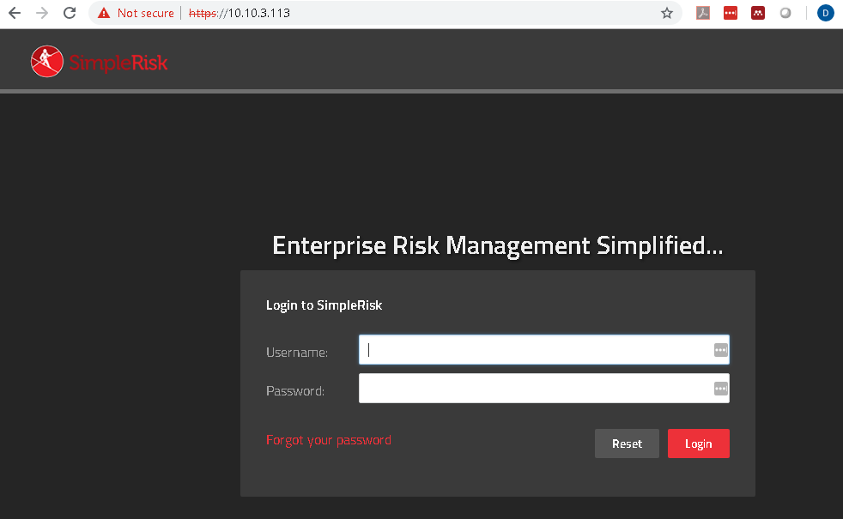

Fll out the “Asset Management” section in SimpleRisk. For each asset fill: Asset name, IP Address, Site/location, Team and Asset Details. In Asset Details you must place the following information:

- Name of the owner
- Name of the responsible
- Name of the custodian
- Name of the area or process where the assets belongs
- Type of asset (Hardware, software, information, network, persons, etc)
- Asset users
- Classification (Publico, Uso interno, Reservado, Confidencial)
- Impact to availability [1-5]
- Impact to confidentiality [1-5]
- Impact to Integrity [1-5]
- Total Impact

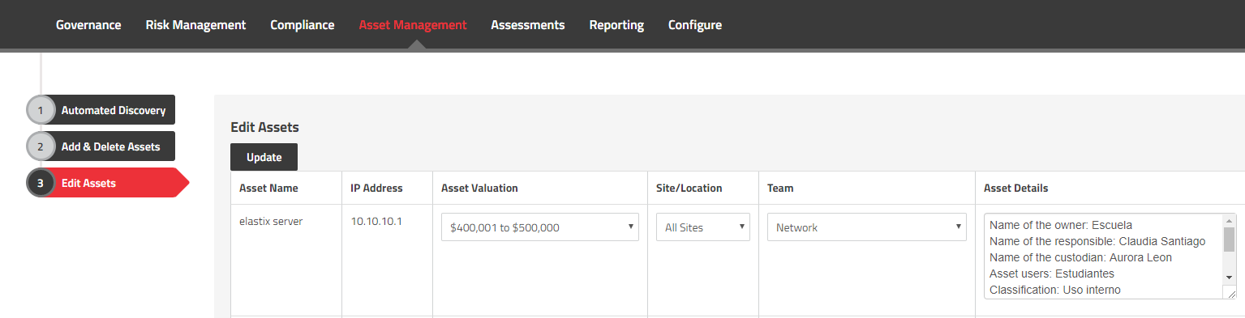

Use the following table to evaluate impact:

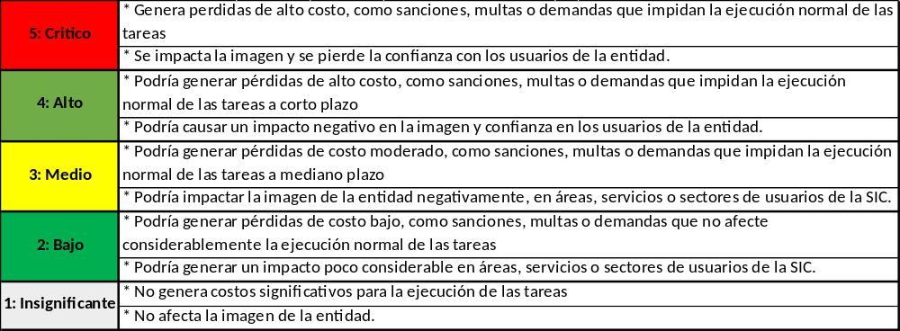

Use the following table to evaluate classification:

Descripción | Nivel de clasificación
El activo puede ser consultado por todo el mundo | Publico
El activo pude ser consultado solo por personal de la entidad | Uso Interno
El activo se considera información Reservada por ley o mandato (Ley 1581 de 2012, Ley 1266 de 2008, etc) | Reservado
El activo puede ser consultado solo por un grupo de personas en particular | Confidencial

Prepare an Executive Summary with the analysis of the information assets that you have just filled in the Excel. Use graphics to represent the information. The executive summary must allow the company manager to know the impact of the assets and make decisions about how to protect the assets.

SECTION FIVE

- For each laboratory session, each student must find out about some security threat that is published by some media. Each class, the teacher can select one student and ask him/her to describe the threat. Some examples of media are:

- https://cyberstreetwise.com/
- http://www.bbc.com/news/technology
- http://www.theguardian.com/media-network/information-security
- http://www.telegraph.co.uk/technology/internet-security/
- http://www.bloomberg.com/topics/cybersecurity

- Understand the basic metrics from the CVSS Score 3.0:
https://www.first.org/cvss/specification-document
Play a bit with the following CVSS Score calculator:
https://www.first.org/cvss/calculator/3.0#CVSS:3.0/AV:N/AC:H/PR:N/UI:R/S:C/C:L/I:N/A:H
- Go to the following link: https://source.android.com/security/bulletin/index.html and describe which was the last Android security bulletin, publication date, number and kinds of security patch levels. For two vulnerabilities included in the bulletin, specify: description of the vulnerability, severity, operative systems affected.

CVE | Type | Severity (Qualitative) | Severity  (Quantitative) | CVSS v3.0 Vector | Describe an exploitation scenario explaining all the metrics included in the CVSS Vector

- The Android Security Bulletin just covers Google mobile phones (Pixel and Nexus), so, ¿Who covers the vulnerabilities from phones of other brands? The answer is that each manufacturer should publish its own security updates. Let’s check for example Samsung Android Security Updates: Go to the following link: http://security.samsungmobile.com/smrupdate.html and describe which was the last Samsung Android Security Update and publication date. For two vulnerabilities included in Samsung Android Security Update, specify: description of the vulnerability, severity, operative systems affected.

CVE | Type | Severity (Qualitative) | Severity  (Quantitative) | CVSS v3.0 Vector | Describe an exploitation scenario explaining all the metrics included in the CVSS Vector

- Find out and define the following terms: Cyber-criminal, Spies, Hacktivists, Insider attacker, Cyber terrorists, Cyber Warriors, Script Kiddies, and Online Social Hackers.

- Find out the meaning of the following terms: Threats, Vulnerability, Security Controls.

- ¿What is the difference between Proprietary, Responsible and custodian for an asset?

Prepare the following two documents to deliver:

- File with the answers to the questions included in the present laboratory
- Executive summary about the company information assets.
- Save the “Asset Management” Tab of simplerisk, in the “Edit Assets” section, as an HTML, so it can be possible to validate the asset information that you have input.

The files must be named in the following way:

- Lab1-Name1LastName1Name2Lastname2Name3Lastname3.pdf
- ExecutiveSummary-Name1LastName1Name2Lastname2Name3Lastname3.pdf
- Asset-Name1LastName1Name2Lastname2Name3Lastname3.html

